Creating an Interior Design proposal that truly resonates with a client demands more than just an eye for aesthetics and knowledge of trends. It requires a deep understanding of the client's preferences, lifestyle, needs, and aspirations. This understanding is depicted in a well thought out client brief, which serves as the foundation for a successful project. Profiling a client and creating a comprehensive client brief ensures that the final design is not only beautiful, but also functional as well as personalised. In this article we will briefly look at the process and elements of profiling a client and the phases required to create a Client Brief, however, detailed information for each one of the elements we look at separately, can be found in your course content.



Fig. 1. Canva (n.d.), An interior designer with their clients

# Step 1: Initial Consultation

The process begins with an initial consultation, where the interior designer meets the client to establish rapport and gather preliminary information. This meeting is crucial for setting the tone of the project and understanding the client's vision. Key areas to explore during this consultation include:

Client’s Objectives: What are the primary goals for the project? Is it a renovation, a new build, or a specific room redesign?

Budget: What is the client’s budget range? This helps in determining the scope and feasibility of the project.

Timeline: What is the desired completion date? Are there any specific deadlines that need to be met?

# Step 2: Understanding the Client’s Lifestyle

and Preferences

To design a space that truly reflects the client’s personality and lifestyle, the designer must look into details such as their daily routines, habits, and preferences. This can be achieved through a detailed questionnaire or an in-depth conversation. Key topics to cover include:

Daily Routine: How does the client use their space on a daily basis? Are there specific activities or functions that the space needs to accommodate?

Personal Style: What are the client’s style preferences? This includes colours, patterns, materials they may or may not prefer, and overall design aesthetics they are drawn to. Hobbies and Interests: What are the client’s hobbies and interests? This can provide insight into design elements that would make the space more personal and enjoyable for them.

Family and Pets: Who lives in the household? Are there any special considerations for children, elderly family members, or pets?



Fig. 2. Canva (n.d.), An Interior Design consultation meeting

# Step 3: Site Analysis

A thorough site analysis is essential to understand the existing conditions and constraints of the space. This involves:

Measuring the Space: Accurate measurements of all rooms and areas that will be redesigned. Analysing the Layout: Understanding the flow and functionality of the current layout.

Identifying Architectural Features: Noting any architectural elements that should be preserved or can be highlighted.

Assessing Natural Light: Observing how natural light enters the space at different times of the day.

It is important for a designer to be constantly mindful of the clients needs and their preferences. This means you cannot make any assumptions and must consistently communicate your design intentions. While you will have garnered a lot of information about the person who will be the principal user of the space, you may need to dig a little deeper and ask questions that the client may not have themselves considered. When planning the space, ensure you ask the client specifics about things like architectural features and whether they wish to incorporate certain elements in the design, or remove them. You will also need to consult with them on traffic flow and whether it best serves the primary function of the space. This level of consultation not only builds trust between the designer and the client, but it can also eliminate any unnecessary and potentially costly changes further down the line.

# Step 4: Gathering Inspiration

Collecting visual inspiration helps in aligning the client’s vision with the designer’s ideas. This can be done through:

Mood Boards: Creating mood boards with images, colors, textures, and materials that resonate with the client’s preferences.

Pinterest Boards: Encouraging the client to share Pinterest boards or other visual collections that reflect their taste.

Design Magazines and Websites: Reviewing design magazines and websites together to identify styles and elements the client likes.

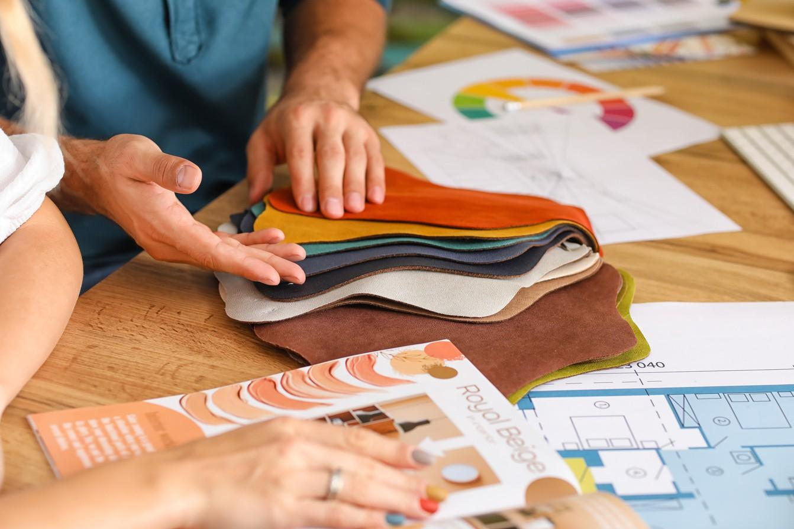

Fig. 3. Canva (n.d.), Samples for Inspiration

# Step 5: Drafting the Design Brief Package

The Design Brief Package is a comprehensive document that consolidates all the gathered information and serves as a roadmap for the project. It typically includes:

Project Overview: A summary of the project’s objectives, scope, and key deliverables.

Client Profile: Detailed information about the client’s lifestyle, preferences, and requirements. Design Goals: Specific design goals and priorities identified during the consultation and profiling stages.

Budget and Timeline: Clear guidelines on the budget and timeline for the project. Site Analysis Report: Findings from the site analysis, including measurements, layout assessments, and notes on architectural features.

Inspirational References: Visual references and mood boards that reflect the agreed-upon design direction.



Fig. 4. Canva (n.d.), Interior Design Package Presentation

# Step 6: Review and Approval

Before proceeding with the design phase, it is crucial to review the client brief package with the client. This ensures that all aspects of the project are clearly understood and agreed upon. During this review:

Discuss and Clarify: Go through each section of the brief with the client, addressing any questions or concerns they may have.

Make Revisions if Necessary: Be open to making adjustments based on the client’s feedback. Obtain Formal Approval: Ensure the client signs off on the brief, indicating their approval and commitment to the outlined plan.

Profiling a client and creating a detailed client brief are fundamental steps in the interior design process. By taking the time to thoroughly understand the client's needs, preferences, and lifestyle, you can create spaces that are not only aesthetically pleasing, but also deeply personalised and functional. This careful preparation sets the stage for a successful and satisfying design project, ensuring that the end result is a true reflection of your client’s vision and desires.